**Task 8.2HD – Answers**

Question #1

<https://youtu.be/iDA7h_SZKME>

Question #2

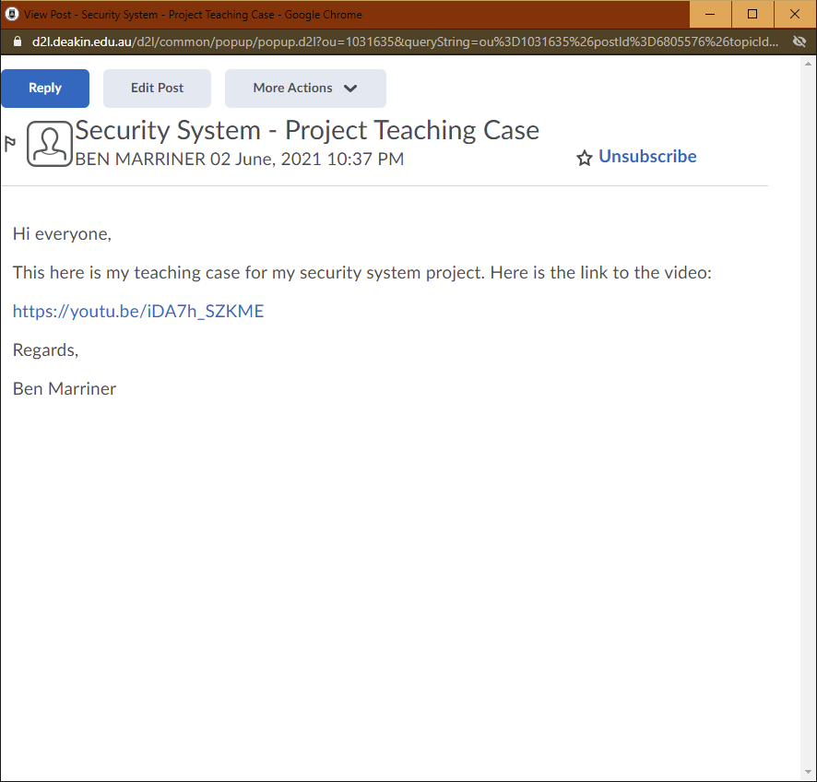

Question #3

After developing and testing a prototype of an idea for a system, it is always important to look back on what you have done to see what was good about the prototype, what did not work and what could be done better next time. This project has pushed me to gain a better understanding of how to prototype systems. This meant understanding how to properly use components such as sensors, particle devices and breadboards. The project also pushed me to think more about how electricity will flow through a circuit to ensure that all components can function properly as well as communicate with Particle Argon. Overall, because of this project, I feel more comfortable working with hardware like particle devices and electrical components that can be connected to it.